Silvio O. Conte Federal Building
78 Center Street, Pittsfield, MA 01201

MAP

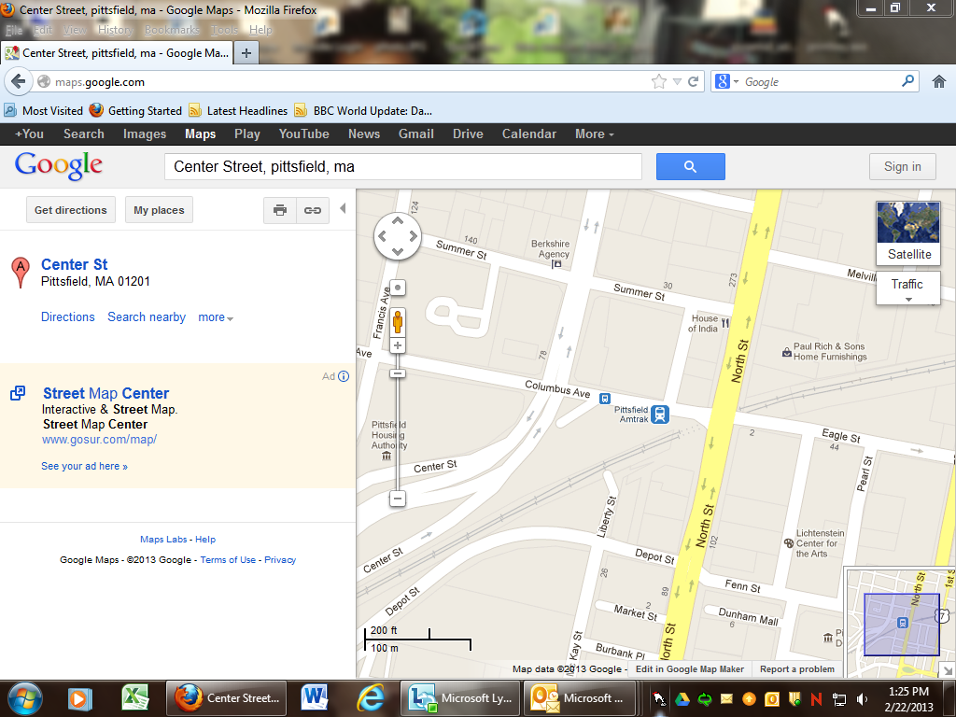
Park here at the Columbus Avenue Parking garage – top level
Massachusetts Nonprofit Network Mtg, room 204A
Conte Federal
Building
Parking garage

