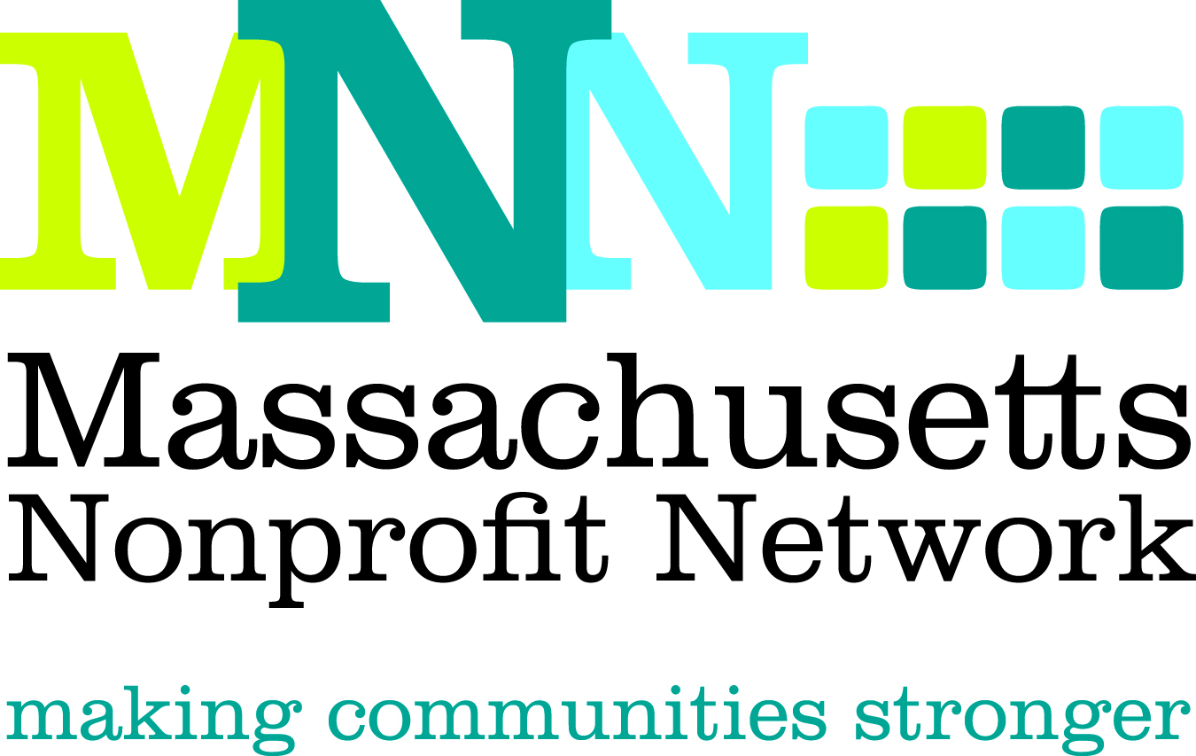

Request for Proposals
2013 MNN Conference Workshops
Background:

The Massachusetts Nonprofit Network is pleased to solicit proposals from individuals, organizations and companies for workshops as part of its annual day long fall conference. Each year this conference attracts over 500 nonprofit staff and consultants from across the state for education and networking opportunities that allow them to return to their work with greater knowledge, fresh skills and new contacts.

The Massachusetts Nonprofit Network is the voice of the nonprofit sector in Massachusetts and understands that strong nonprofit organizations build strong communities. MNN has over 500 member organizations, representing every part of Massachusetts—from the Berkshires to the Cape. MNN’s goals are to promote the image of the nonprofit sector; strengthen the nonprofit sector through advocacy and public policy; and build the capacity of nonprofits across the state.

Conference Theme:

The 2013 MNN Conference will focus on how nonprofits can become more productive and efficient by using the individual or combined force of people and technology to develop solutions that they can take back to work the next day and use in the months to come. The conference will connect nonprofits to emerging technologies, professional expertise, and the wisdom of their peers. The nonprofit sector is fortunate to have so many technology-based solutions to its everyday dilemmas, large and small, that it can embrace without losing the human, personal aspect that makes the sector so special. The result is a smoother and more efficient workday for all nonprofit professionals, no matter what their role, that increases their personal effectiveness and their organization's impact.
Date and Location

The 2013 MNN Conference will be held on Tuesday, October 29, from 9am to 4pm at the Sheraton Hotel in Framingham.

Workshop Selection:

Two sessions of 75 minute workshops will be held. A total of eleven workshops will be selected for each session, for a total of 22 workshops. Please note this represents a change from previous years. Topic areas will be more limited than in the past to focus on those that have been the most popular. The topics are as follows:

- Fundraising/Development
- Outcomes measurement/use of data/planning/evaluation
- Leadership
- Board roles/engagement
- Collaboration/mergers
- Marketing/communication

The Conference Committee will be making the workshop selections, and because of the limited number of workshops, the process will be highly selective.

Criteria:

The Conference Committee will use the following criteria in selecting the workshops:
- Fits well within one of the six topic areas
- Incorporates the conference theme elements of people, technology or the combined force of both
- Provides at least three takeaways that attendees can apply to their work
- Addresses a common workplace or organizational problem and provides solutions
- Engages the audience and uses an appropriate format that can be delivered in allotted time
- Provides insight and/or greater understanding of emerging trends or changes that produce effective solutions to common nonprofit challenges
- Title and workshop description are clear and compelling
- Presenters have proven track record of offering successful presentations on the topic
- Overall quality of workshop and learning outcomes

Target Audience: Conference attendees in the past have been primarily nonprofit staff in senior positions.

Deadline: The deadline for all proposal submissions is May 21, 2013.

Submission Instructions:
Please answer the questions below and return ONLY THE PROPOSAL FORM, which begins on the following page (please do not include this page in your submission).

Email all completed proposals saved as the title of your workshop to Hillary Kovash at hkovash@massnonprofitnet.org and include “Conference Workshop Proposal” in the subject line.

Additional Information:
Refer to the Conference Workshop FAQ page on the MNN website for more information about the MNN Annual Conference and the conference workshop selection process.

Questions: Please contact Hillary Kovash at hkovash@massnonprofitnet.org or call 617-330-1188x281 or refer to the MNN Conference Workshop Proposal FAQ sheet on the MNN website.

2013 MNN Conference Workshop Proposal Form
**Please answer the questions below and return ONLY THIS PORTION to the MNN office.** Submissions are due May 21, 2013 and should be saved with title of your workshop and sent to hkovash@massnonprofitnet.org

- Workshop Title: ____________________________________________________________________________

- Please give a brief description of your workshop. (200 word limit)
_________________________________________________________________________________________________________________________________________________________________________________________________________________________________________________________________________________________________________________________________________________________________________________________________________________________________________________________________________________

- Presenter Name(s)/Organization(s)/Affiliation(s):
Name:____________________________________________________________________________________Organization/Affiliation: _____________________________________________________________________
City/State: ________________________________________________________________________________

- Category (select one):
Fundraising/Development
Outcomes measurement/use of data for planning and evaluation
Leadership
Board roles/engagement
Collaboration/mergers/partnerships
Marketing/Communications

- What are the three or more concrete solutions that participants will take away from this workshop? (150 word limit)
____________________________________________________________________________________________________________________________________________________________________________________________________________________________________________________________________________________________________________________________________________________________________________________

- How will participants become more productive and more efficient using the individual or combined force of people and technology to provide solutions because of your workshop? (150 word limit)
____________________________________________________________________________________________________________________________________________________________________________________________________________________________________________________________________________________________________________________________________________________________________________________

- How will your workshop engage participants and utilize their expertise and knowledge? (150 word limit)
____________________________________________________________________________________________________________________________________________________________________________________________________________________________________________________________________________________________________________________________________________________________________________________

- Where and when have you presented on this topic previously?
_______________________________________________________________________________________________________________________________________________________________________________________________________________________________________________________________________________________

- Solution focus (please select one)
People
Technology
Both

- Format: (please select one)
- Experiential Training
- Open Forum/Discussion
- Presentation/Lecture
- Panel
- Other, please describe:

- Level: (please select one)
- Introductory (for attendees with little knowledge or experience/focuses on basics or broad overviews)
- Intermediate (for attendees with some knowledge or experience/focuses on building on a basic foundation to strengthen skills)
- Advanced (for attendees with extensive knowledge and/or experience/focuses on presenting new or innovative trends and strategies and/or requires a high level of previous knowledge)

- This workshop is geared toward: (please select one)
- Small organizations (less than 10 full-time employees)
- Mid-sized organizations (10-50 full-time employees)
- Large organizations (more than 50 full-time employees)
- Organizations of all sizes

- Please describe your target audience, e.g. Executive Directors, human service providers, mid-career professionals, etc. (50 word limit)
_______________________________________________________________________________________________________________________________________________________________________________________________________________________________________________________________________________________

- Please provide a brief bio for ALL presenters. (maximum of 100 words each, to include bios of all presenters) ____________________________________________________________________________________________________________________________________________________________________________________________________________________________________________________________________________________________________________________________________________________________________________________

- References who can provide information about you previous presentations of this topic (may be used to assist the Selection Committee in making its decision):
Name: ___________________________________________________________________________________
Relationship: ______________________________________________________________________________
Email/Phone: ______________________________________________________________________________

Name: ___________________________________________________________________________________
Relationship: ______________________________________________________________________________
Email/Phone: ______________________________________________________________________________

Name: ___________________________________________________________________________________
Relationship: ______________________________________________________________________________
Email/Phone: ______________________________________________________________________________

- Please provide URL to any videos of past presentations:

- Please list name, organizational affiliation, and email address for ALL presenters:
Name: ____________________________________________________________________________________
Organization: ______________________________________________________________________________
Email/Phone: ______________________________________________________________________________
Website: __________________________________________________________________________________
Address: __________________________________________________________________________________
City: _________________________________ State: ____________ Zip: _______________________________

Name: ___________________________________________________________________________________
Organization: ______________________________________________________________________________
Email/Phone: ______________________________________________________________________________
Website: __________________________________________________________________________________
Address: __________________________________________________________________________________
City: _________________________________ State: ____________ Zip: _______________________________

- Main Contact Information:
The main contact will receive all workshop-related communications and will be responsible for communicating this information to their co-presenters, as necessary.
Name: ___________________________________________________________________________________
Organization: ______________________________________________________________________________
Email/Phone: ______________________________________________________________________________
Website: __________________________________________________________________________________
Address: __________________________________________________________________________________
City: _________________________________ State: ____________ Zip: _______________________________

