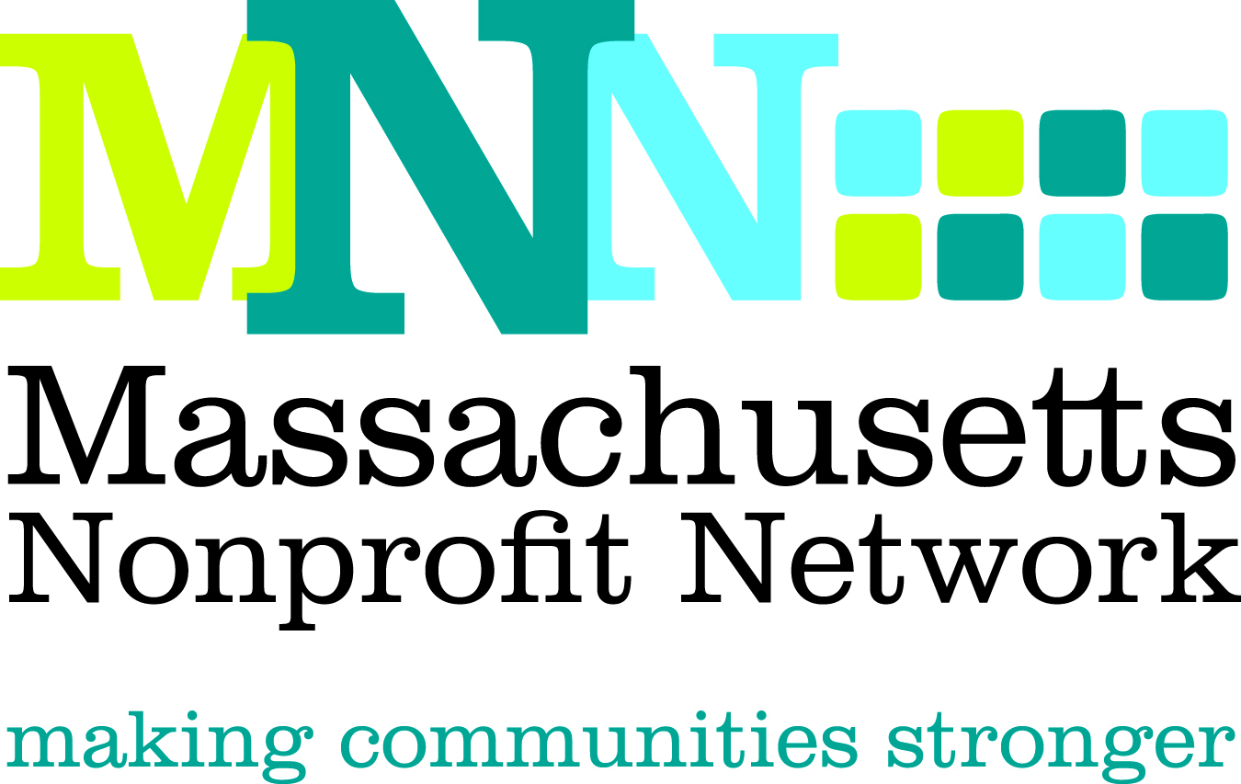

Collaboration Excellence Award Nomination

The Excellence Award in Collaboration recognizes the lead organization in an effort by two or more nonprofit organizations that have partnered to address a problem that could not have been solved as effectively by the individual organization(s).

Nominations will effectively convey the following criteria about the collaboration:

- Identified an approach to respond to a pressing need which could be better addressed by working collaboratively
- Achieved goals by communicating effectively, sharing information, and instituting clear guidelines and a process for accountability
- Demonstrated effective allocation and use of combined resources in a way that furthered the missions of all involved organizations
- Achieved meaningful and measureable outcomes that were made possible through collaborative efforts

Deadline: The deadline for all nominations is March 12, 2013.

Submission Instructions:
Please answer the questions below and return ONLY THE NOMINATION FORM, which begins on the following page (please do not save this page in your submission).

Email all completed nominations, as a word document (not a PDF), to Hillary Kovash at hkovash@massnonprofitnet.org and include “Collaboration Nomination, Nominee’s Last Name” in the subject line.

Additional Information:
Refer to the Excellence Award FAQ page on the MNN website for more information about Nonprofit Awareness Day and the Excellence Award judging process.

Questions:
Please contact Hillary Kovash at hkovash@massnonprofitnet.org or 617-330-1188x281.

Collaboration Excellence Award Nomination Form
**Please answer the questions below and return ONLY THIS PORTION to hkovash@massnonprofitnet.org.**

- Nominee Information:
Name: ___________________________________________________________________________
Title: _____________________________________________________________________________
Organization: ______________________________________________________________________

- Provide a brief overview of the lead organization, including mission, approximate size and date established, programs and services offered, and populations served, as well as relevant information about the collaborating organizations. (200 word limit)
__________________________________________________________________________________________________________________________________________________________________________________________________________________________________________________________________________________________________________________________________________________________________________________________________________________________

- Briefly describe the target need or issue identified and the steps taken through the collaborative efforts to address the need or issue. (200 word limit)
________________________________________________________________________________________________________________________________________________________________________________________________________________________________________________________________________________________________________________________________________

- With the above criteria in mind, describe why this collaborative effort would qualify them for this award. Please use specific examples. (200 word limit)
__________________________________________________________________________________________________________________________________________________________________________________________________________________________________________________________________________________________________________________________________________________________________________________________________________________________

- Provide a clear description of the outcomes achieved in this area and how the actions described above led to these outcomes. Please be as specific as possible. (200 word limit)
________________________________________________________________________________________________________________________________________________________________________________________________________________________________________________________________________________________________________________________________________

- Nominee Contact Information:
Name: ____________________________________________________________________________
Email Address: _____________________________________________________________________
Phone: ___________________________________________________________________________

- Nominator Contact Information: (Please leave blank if self-nominating.)
Name: ____________________________________________________________________________
Email Address: _____________________________________________________________________
Phone Number: ____________________________________________________________________

